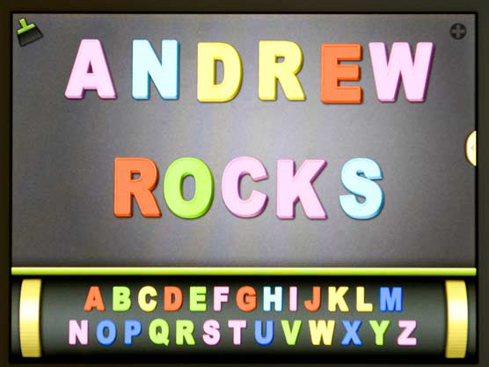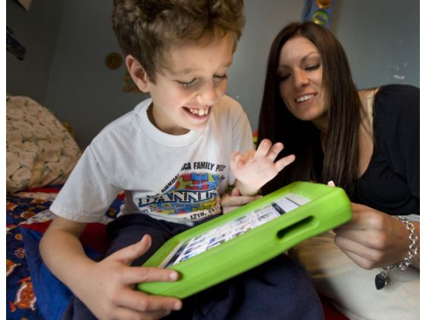

Orange County Register-11/30/11 Andrew presses icons that represent words and ideas, which his iPad then

“speaks.” His mother says the tablet computer has helped him make dramatic communication progress in a few months.

**Early Literacy for ALL youngsters; A Key to Unlock Their Voices**

**Dr. Jean M. Casey**

Andrew was labeled Autistic. His family tried many ways to communicate with him unsuccessfully, that is, until one man’s vision for a technological revolution became the answer to thousands of prayers from families just like them. It was Gary James founder of **Apps for Children with Special Needs (A4CWSM website)** a comprehensive website where parents can view videos and read reviews about specific apps. James realized the iPad was more than just another device for the tech-savvy crowd when he saw the difference it made for his own special-needs son. With a 6-year-old labeled autistic and non-verbal he understood what families were going through. Knowing how much the iPad has helped his child made him realize how many other children out there could be benefit from this technology. James said, “Knowing how much the iPad can change just one life, if I could, I would give an iPad to every single special needs child. Research shows that iPads also help toddlers between ages 3 and 4 with cortical visual impairment. The iPads run an app called **Baby Finger,** which kids can tap and colored shapes appear. The results were remarkable as a therapy tool for these children. (Saunders, 2011)

Outside of school technology has exploded, with 70 % of children ages 2-17 using computers. Children use iPhones, iPads, wireless Internet networks, and video games. See: Best iPad Apps for Kids on your computer! [http://www.ipadnewsdaily.com/78-best-ipad-apps-for kids.html](http://www.ipadnewsdaily.com/78-best-ipad-apps-for%20kids.html)

California's public schools serve students from across the spectrum, including many with milder symptoms. Since schools started tracking autism in 1991, the caseload has climbed precipitously — to nearly 14,000 by 2000 and nearly 70,000 by 2010. Why are so many children being labeled!

To contact Dr. Casey for more information: Faculty Member, National University, Costa Mesa, CA. [jean.casey@natuniv.edu](mailto:jean.casey@natuniv.edu) <http://jean.casey.com> [jeancasey@aol.com](mailto:jeancasey@aol.com)

Books by Dr. Jean M. Casey- Early Literacy: The Empowerment of Technology and Creating the Early Literacy Classroom Available on: Amazon.com or from ABC-CLIO, P.O. Box 1911, Santa Barbara, CA 92116-1911

Dr. Peets Writing Buddy and ABCBuddy apps available for iPad on iTunes.

KidWorks Deluxe or Jump Start Software, www.knowledge adventure.com